Linux Servers
Classroom Assignment 2 – Users, groups, owners and permissions
Document your commands or take screenshots. Answer questions in english or finnish.

Users
Add new user accounts with the names admin and sulo. Also add user with your own student-id (ex. e6210). Set a password for all users. Keep names lowercase.
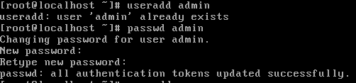
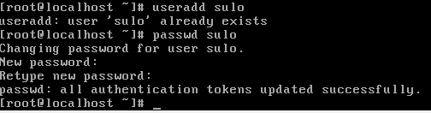
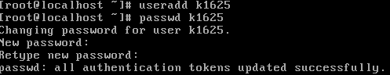
Lisäsin käyttäjät admin, sulo ja k1625

Check with the id command what user ids are assigned to users?
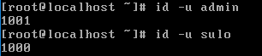
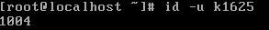
Id –u komennolla pystyi katsomaan käyttäjien id:t.

Group and sudo
Add a group named engineers and add your student-id account to the group (as a secondary group). Wheel-group is already created, add the admin account to that group. Log on as admin and test that you can use sudo now. Log on as sulo and check what error message you get when you try to use sudo?
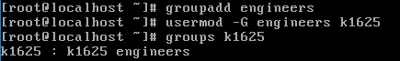
Lisäsin engineers ryhmän ja lisäsin sinne k1625 käyttäjän.
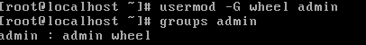
Lisäsin admin käyttäjän wheel grouppiin, jotta se saa tarvittavat oikeudet.
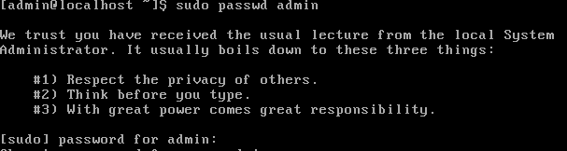
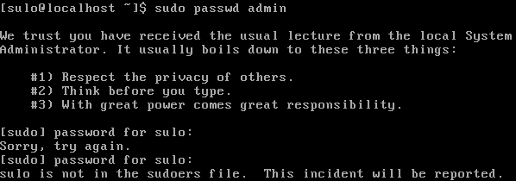
Adminilla sudo passwd komento toimi, sulolla ei.
In the future assignments, use the admin account and sudo when configuring.

Permissions
Create a directory /home/help. Set the following for the folder:
- Owner admin
- Group engineers
- Permissions: Owner and group has all, others have read and execute.
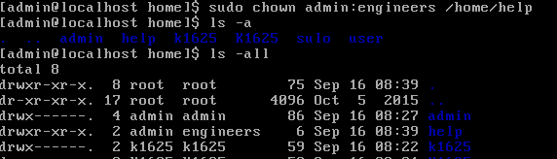
Vaihdoin help kansion omistajaksi admin ja ryhmäksi engineers.
Set the permissions numerically.
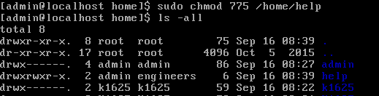
Kansion oikeudet laitettiin kuntoon.
Log on as your student-id account and make a new file in the help directory. Log on as sulo and test that you can read the file but cannot modify it or create new files in the directory.
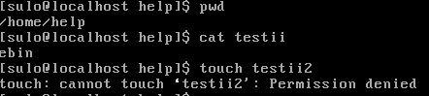
Sulo käyttäjä pystyy tulostamaan testi tiedoston sisällön, mutta ei pysty muokkaamaan tai tekemään uusia tiedostoja

Locking/unlocking user
Lock the password for user sulo and test that you cannot log on. Remove the lock.
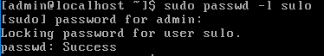
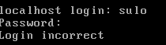
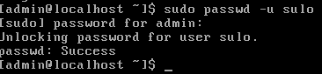
Salasanan lukitsiminen toimi.

Configuration file example
Configure NTP. Open /etc/chrony.conf and determine what syntax is used (what marks a comment, how is a parameter configured). What lines mark the used NTP servers? Comment these lines and add a new line that makes the NTP server ntp.labranet.jamk.fi.
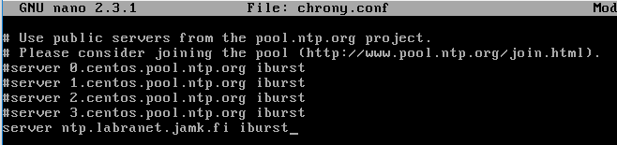
NTP-serveriksi laitettiin labranetin NTP-serveri.

Logs
Find in the logs or journal (use grep or journalctl):
- When the system has booted
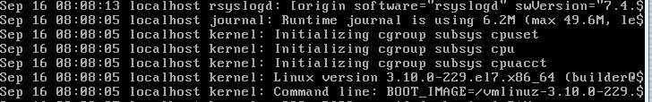
Järjestelmä käynnistettiin 16.9 klo 08:08
- When you created the admin account
Admin käyttäjä luotiin 16.9 klo 08:11
- When sulo tried to use sudo and when he tried to log with the locked password
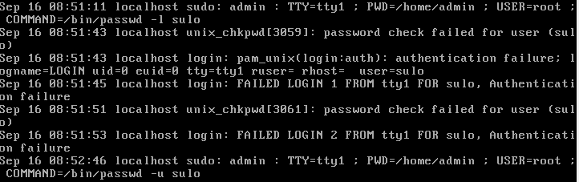
Sulo käyttäjällä yritettiin kirjautua sisään klo 08:51

